**UR number: CTJ+ (lab use only)**

**Surname: ___________ (study ID)**

**Name: T3**

**DOB: Sex:**

**Collection Date:**

**Collection time:**

## 2019384~MH

ICU /CTI CTMH

MACC03~MH

A/PROF CHRIS MACISAAC

ICU

RMH

MH

**LAB PROCESSING INSTRUCTIONS – samples must be frozen within 30 minutes**

CT40P

URGENT PROCESSING REQUIRED

**Specimen type:**

**EL**

**FL**

Pathology Approved Trial

HOME-AKI STUDY

Collection centre: CTMH~MH

Bill Category: 2019384~MH

Contact: Ben Sansom, 0455 300 038

Contact: Andrea/Deb, ext 27710 (ICU)

### PATHOLOGY CLINICAL TRIALS

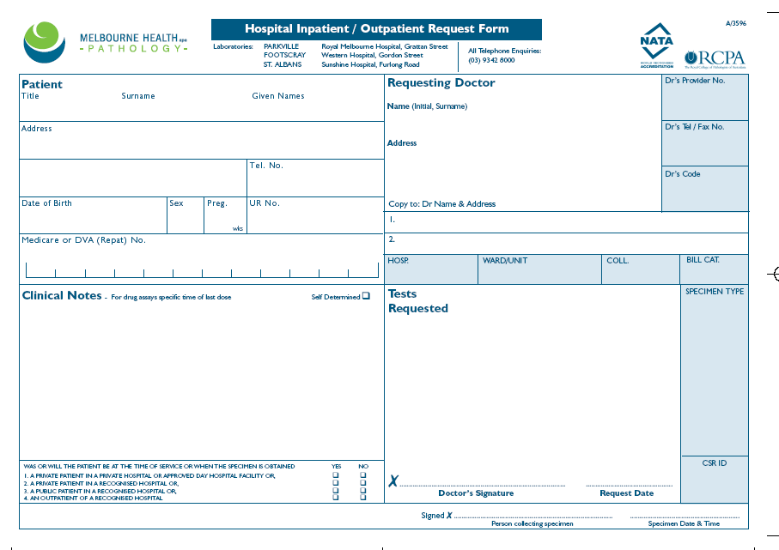

**Register in Auslab**

Label aliquot tubes with Auslab labels for EDTA plasma (EPx)

Freeze at -80C in designated freezer box (or Biochemistry -80C freezer if out of hours)

***trial lab - use small labels (sample type EPX)

**EDTA SAMPLE**

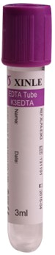

Centrifuge

Transfer 2ml

plasma to 5 x 2ml

tubes

**EFFLUENT SAMPLES**

You will receive 5 tubes of fluid. No processing required.

Label with Auslab barcodes for “FL” and freeze at -80C in the designated study box (or Biochemistry freezer if out of hours)