**UR number: CTJ+ (lab use only)**

**Surname: ___________ (study ID)**

**Name: T2**

**DOB: Sex:**

**Collection Date:**

**Collection time:**

## 2019384~MH

ICU /CTI CTMH

MACC03~MH

A/PROF CHRIS MACISAAC

ICU

RMH

MH

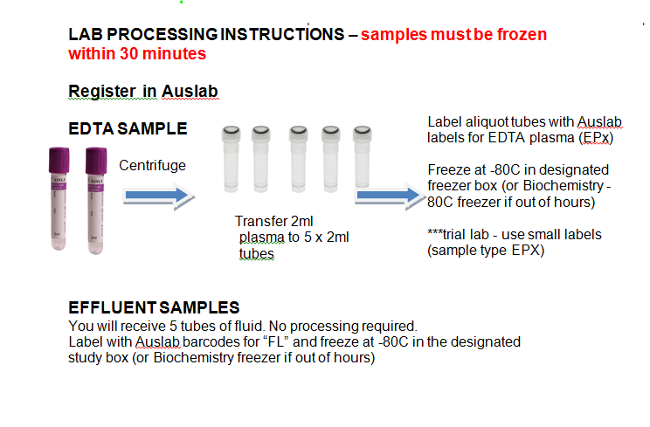

CT40P

URGENT PROCESSING REQUIRED

**Specimen type:**

**EP**

**FL**

Pathology Approved Trial

HOME-AKI STUDY

Collection centre: CTMH~MH

Bill Category: 2019384~MH

Contact: Ben Sansom, 0455 300 038

Contact: Andrea/Deb, ext 27710 (ICU)

### PATHOLOGY CLINICAL TRIALS

